Lab 2: Windows Networking Utilities and DHCP Network Configuration

2.1) Study of Windows Networking Commands
Objective: To study and perform Windows Command Prompt utilities used for network configuration, troubleshooting, monitoring and administration

Theory
Windows provides a collection of built-in networking utilities through the Command Prompt (CMD). These commands help users view, configure, test, and troubleshoot network settings without using the graphical interface. Network administrators commonly use these utilities to diagnose connectivity issues, verify IP configurations, monitor active network connections, manage shared resources, and inspect network communication.
The following commands were studied during this experiment.
1. ipconfig
The ipconfig command displays the basic TCP/IP configuration of the computer, including the IPv4 address, subnet mask, and default gateway. It is commonly used to verify the current network configuration.
Syntax: ipconfig
2. ipconfig /all
The ipconfig /all command displays detailed network configuration information for all adapters, including MAC address, DHCP status, DNS servers, and lease details. It is useful for network troubleshooting.
Syntax: ipconfig /all
3. ipconfig /release
The ipconfig /release command releases the current IP address assigned by the DHCP server for a network adapter. It disconnects the adapter from the network until a new address is obtained.
Syntax: ipconfig /release

4. ipconfig /renew
The ipconfig /renew command requests a new IP address from the DHCP server after releasing the previous one. It is commonly used to refresh network connectivity.
Syntax: ipconfig /renew
5. ipconfig /flushdns
The ipconfig /flushdns command clears the DNS resolver cache stored on the computer. It helps resolve issues caused by outdated or incorrect DNS records.
Syntax: ipconfig /flushdns
6. ping <website>
The ping command tests connectivity between the local computer and a remote host by sending ICMP Echo Request packets. It also measures the response time and packet loss.
Syntax: ping <website>
7. ping <website> -t
The -t option makes the ping command send packets continuously until it is manually stopped. It is useful for monitoring network stability over time.
Syntax: ping <website> -t
8. ping <website> -l 1000 -t
The -l option specifies the packet size in bytes, while -t sends packets continuously. This command is used to test network performance using larger packet sizes.
Syntax: ping <website> -l 1000 -t
9. tracert <website>
The tracert command traces the route taken by packets from the local computer to a destination host. It displays each router (hop) along the path and the response time.
Syntax: tracert <website>
10. nslookup
The nslookup command is used to query DNS servers and obtain information about domain names and IP addresses. It can also be used in interactive mode for multiple queries.
Syntax: nslookup
11. nslookup > <website>
In interactive mode, entering a website or domain name retrieves its corresponding DNS records, such as IP addresses. It helps verify DNS name resolution.
Syntax: nslookup <website>
12. netstat
The netstat command displays active network connections, listening ports, and network statistics. It is useful for monitoring communication between the computer and the network.
Syntax: netstat
13. netstat -an
The -an option displays all active connections and listening ports in numerical format without resolving hostnames. It provides detailed information for network analysis.
Syntax: netstat -an
14. arp -a
The arp -a command displays the Address Resolution Protocol (ARP) cache, showing the mapping between IP addresses and MAC addresses on the local network.
Syntax: arp -a
15. hostname
The hostname command displays the name of the local computer on the network. It is commonly used to identify a system within a network environment.
Syntax: hostname
16. getmac
The getmac command displays the MAC (Media Access Control) addresses of the network adapters installed on the computer. It is useful for identifying network interfaces.
Syntax: getmac
17. net share
The net share command displays or manages shared folders and resources on the local computer. It allows users to view existing shared resources or create new ones.
Syntax: net share
18. net start
The net start command displays all currently running services or starts a specified Windows service. It is commonly used for service management.
Syntax: net start [service_name]
19. net stop
The net stop command stops a specified Windows service. It is used to temporarily disable services for maintenance or troubleshooting.
Syntax: net stop <service_name>
20. color
The color command changes the text and background colors of the Command Prompt window. Different hexadecimal values can be used to customize the display.
Syntax: color <attribute> (e.g., color 0A)

Components Required
- Windows OS
- Command Prompt (cmd)
- Network Connection

1. Viewing Basic IP Configuration
i) Open Command Prompt.
ii) Execute: ipconfig
iii) Observe the IP address, subnet mask, and default gateway.
Output: 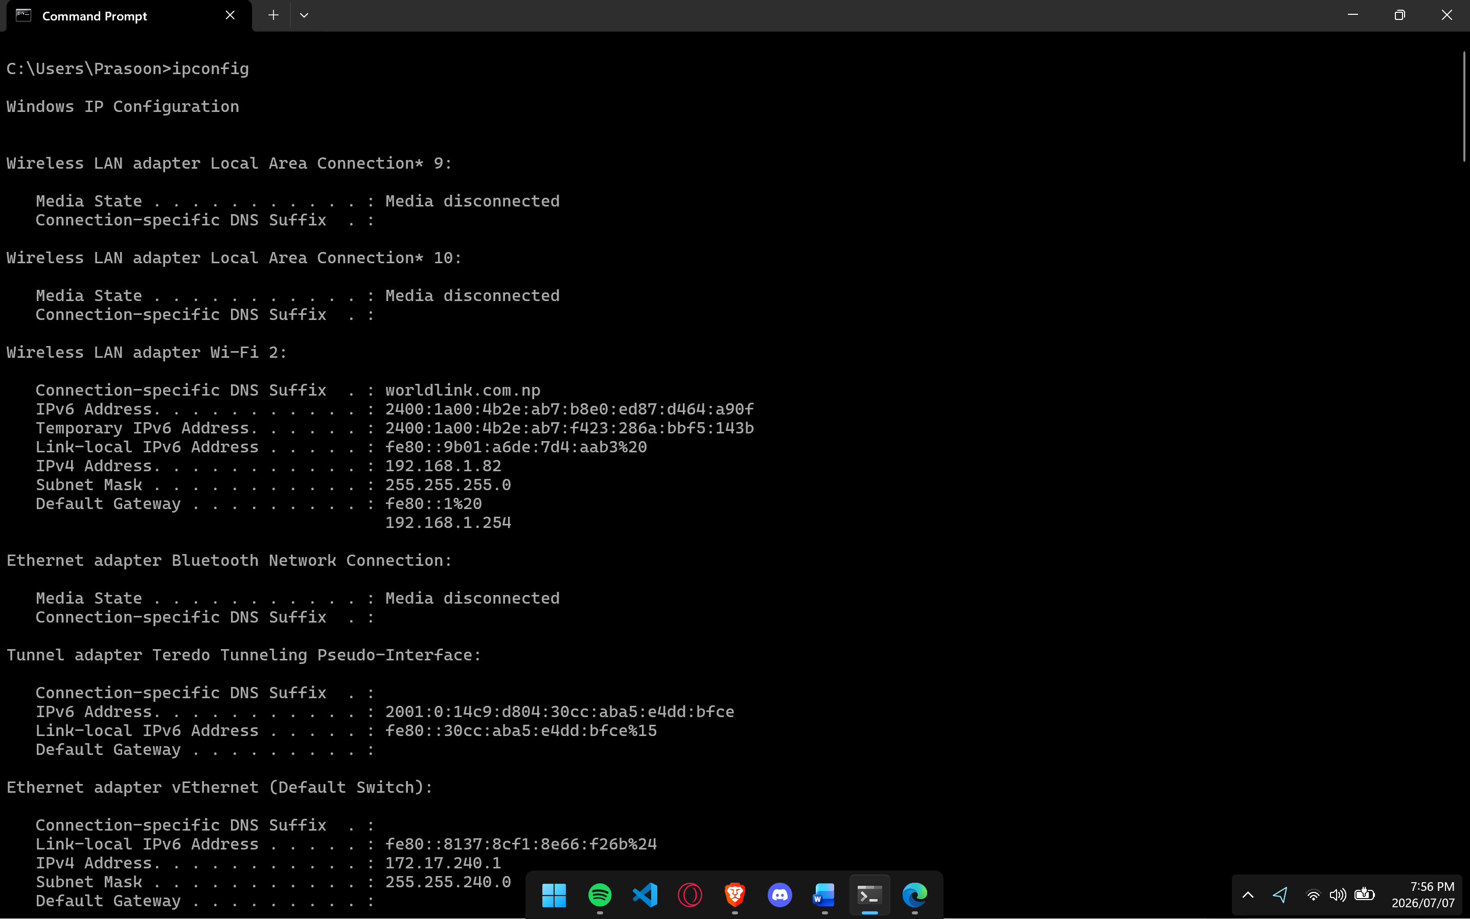

2. Viewing Detailed IP Configuration
i) Open Command Prompt.
ii) Execute: ipconfig /all
iii) Observe detailed information such as MAC address, DHCP status, DNS servers, and lease information.
Output: 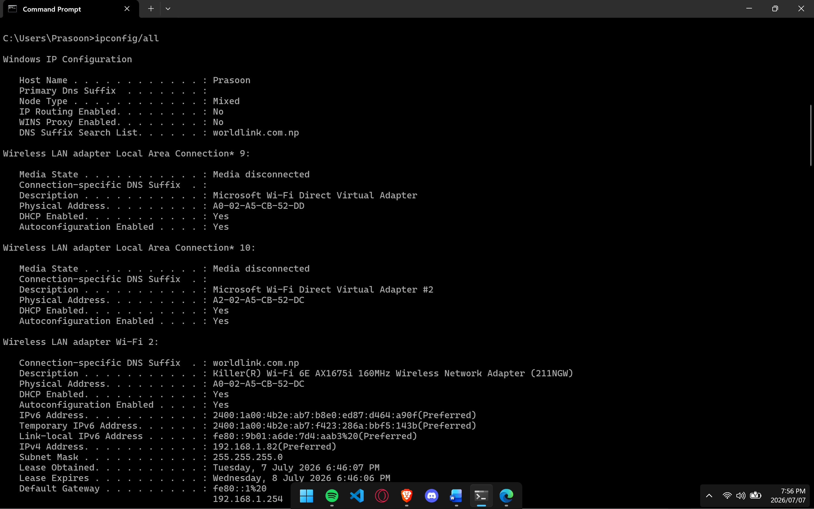

3. Releasing the IP Address
i) Open Command Prompt.
ii) Execute: ipconfig /release
iii) Observe that the current DHCP-assigned IP address is released.
Output: 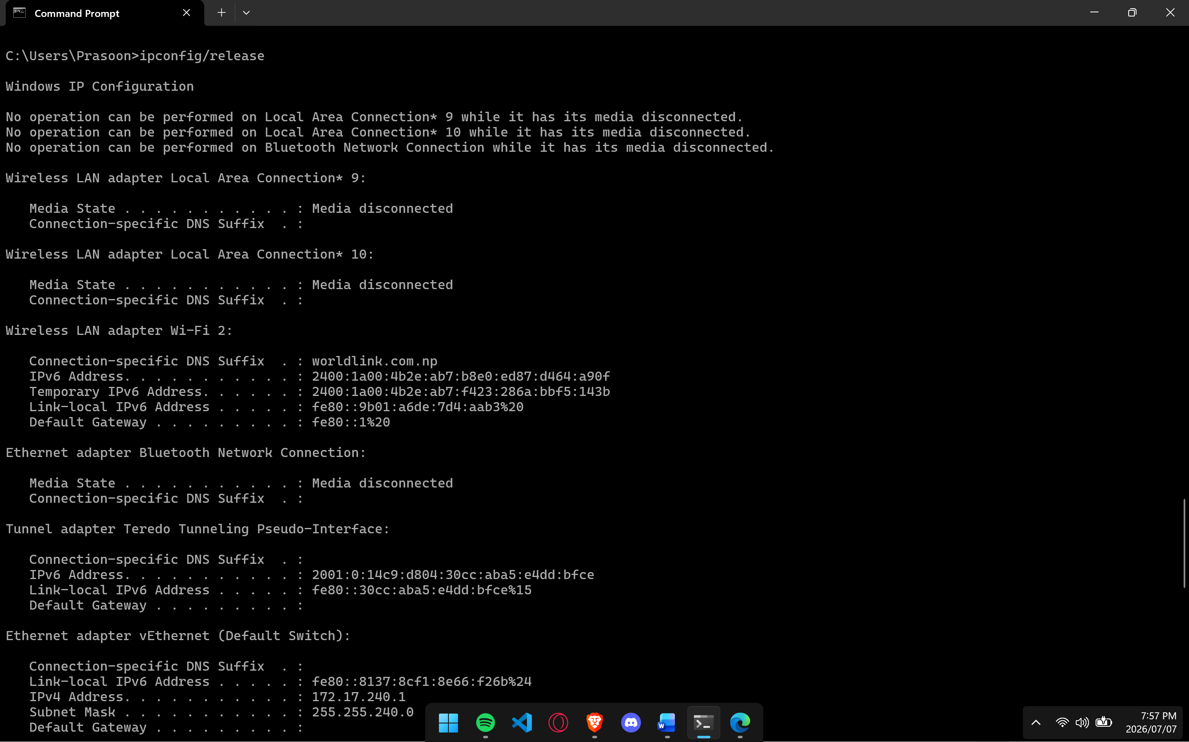

4. Renewing the IP Address
i) Open Command Prompt.
ii) Execute: ipconfig /renew
iii) Observe that a new IP address is obtained from the DHCP server.
Output: 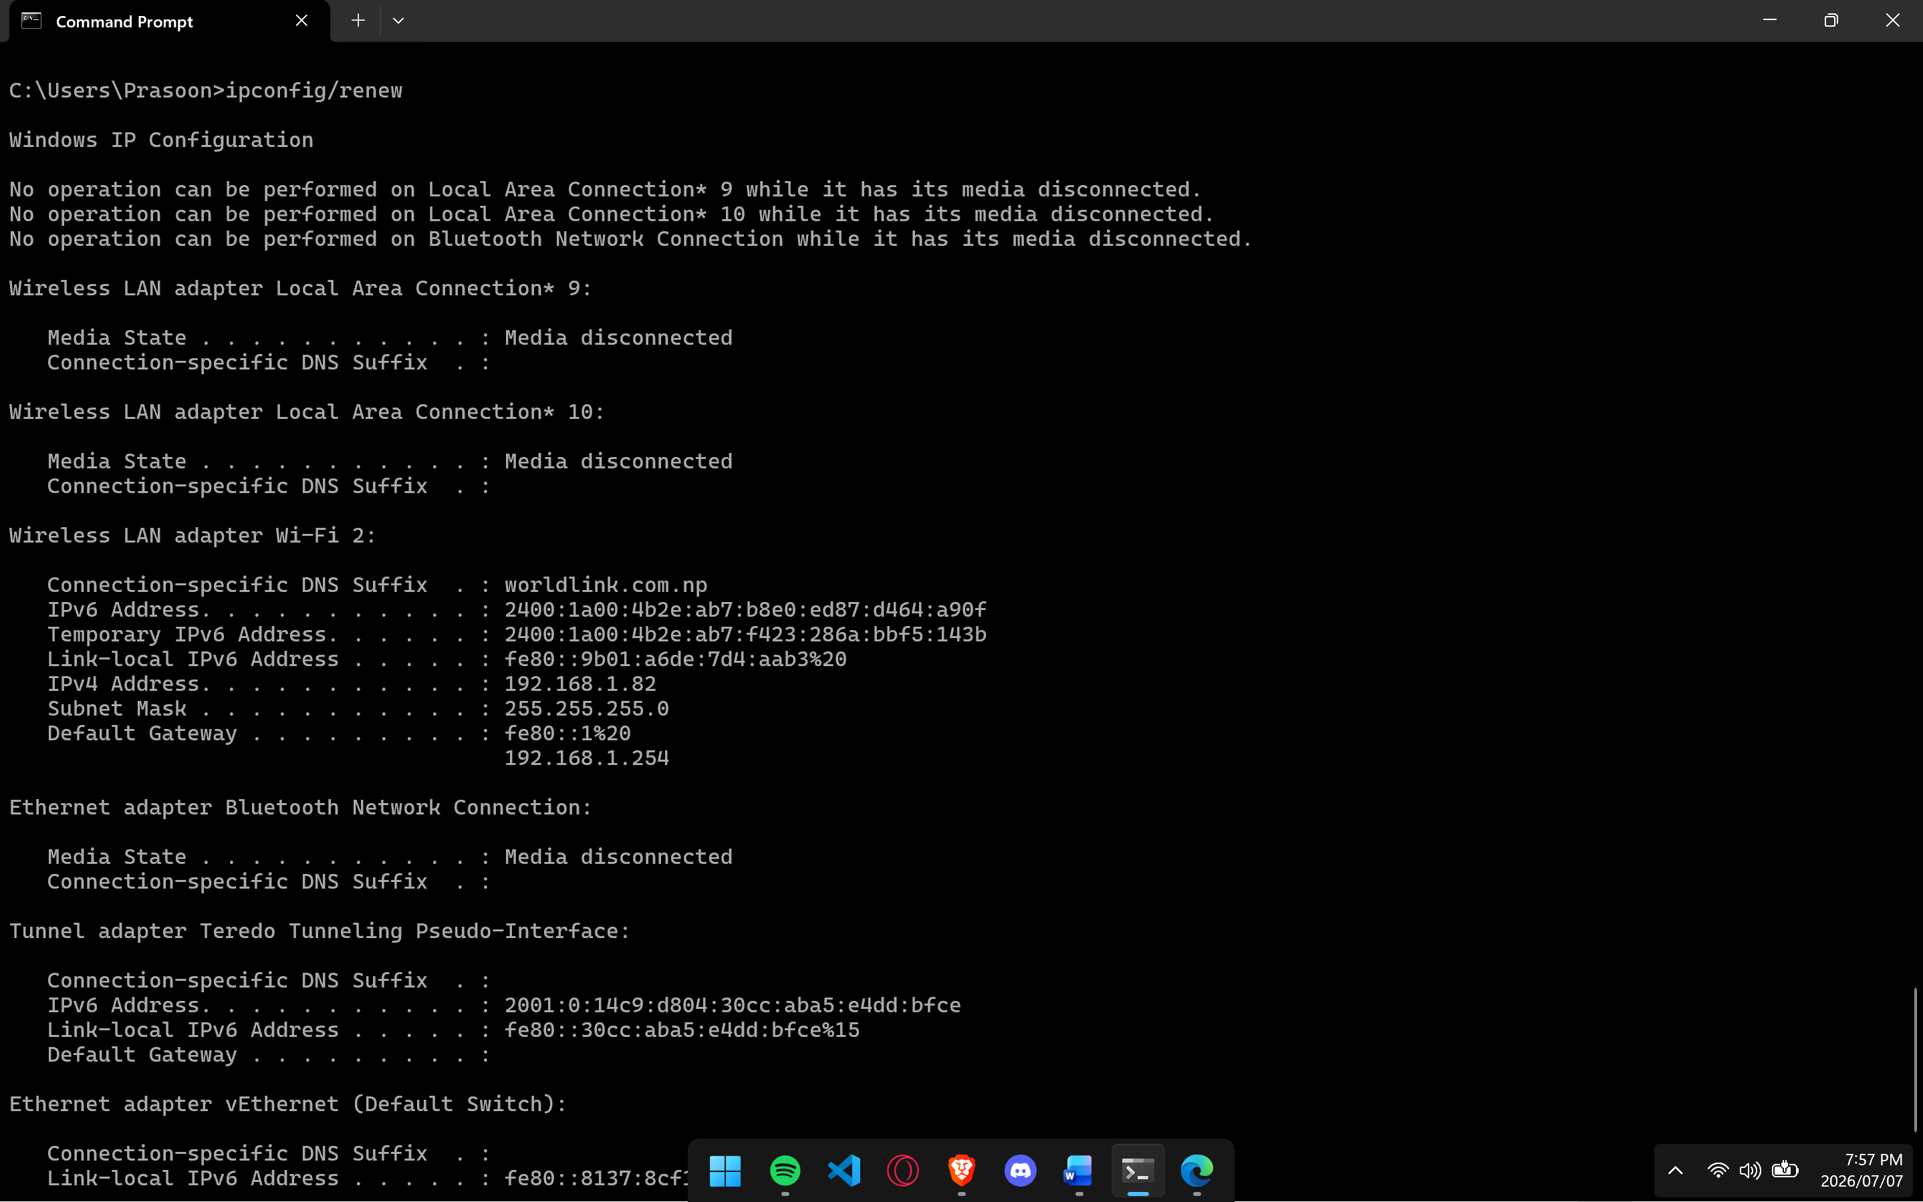

5. Flushing the DNS Cache
i) Open Command Prompt.
ii) Execute: ipconfig /flushdns
iii) Verify that the DNS Resolver Cache has been successfully flushed.
Output: 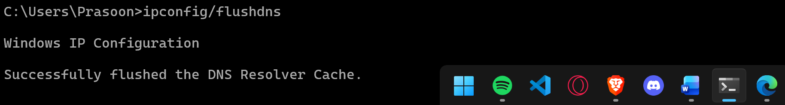

6. Testing Network Connectivity
i) Open Command Prompt.
ii) Execute: ping <website>
iii) Observe the reply messages, response time, and packet statistics.
Output: 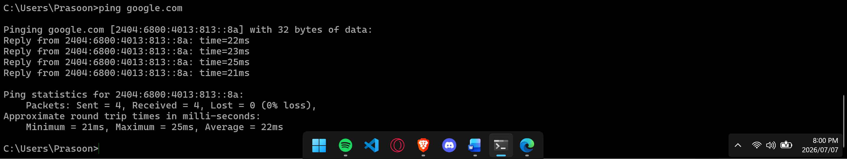

7. Continuous Ping Test
i) Open Command Prompt.
ii) Execute: ping <website> -t
iii) Observe the continuous replies until the command is stopped using Ctrl + C.
Output: 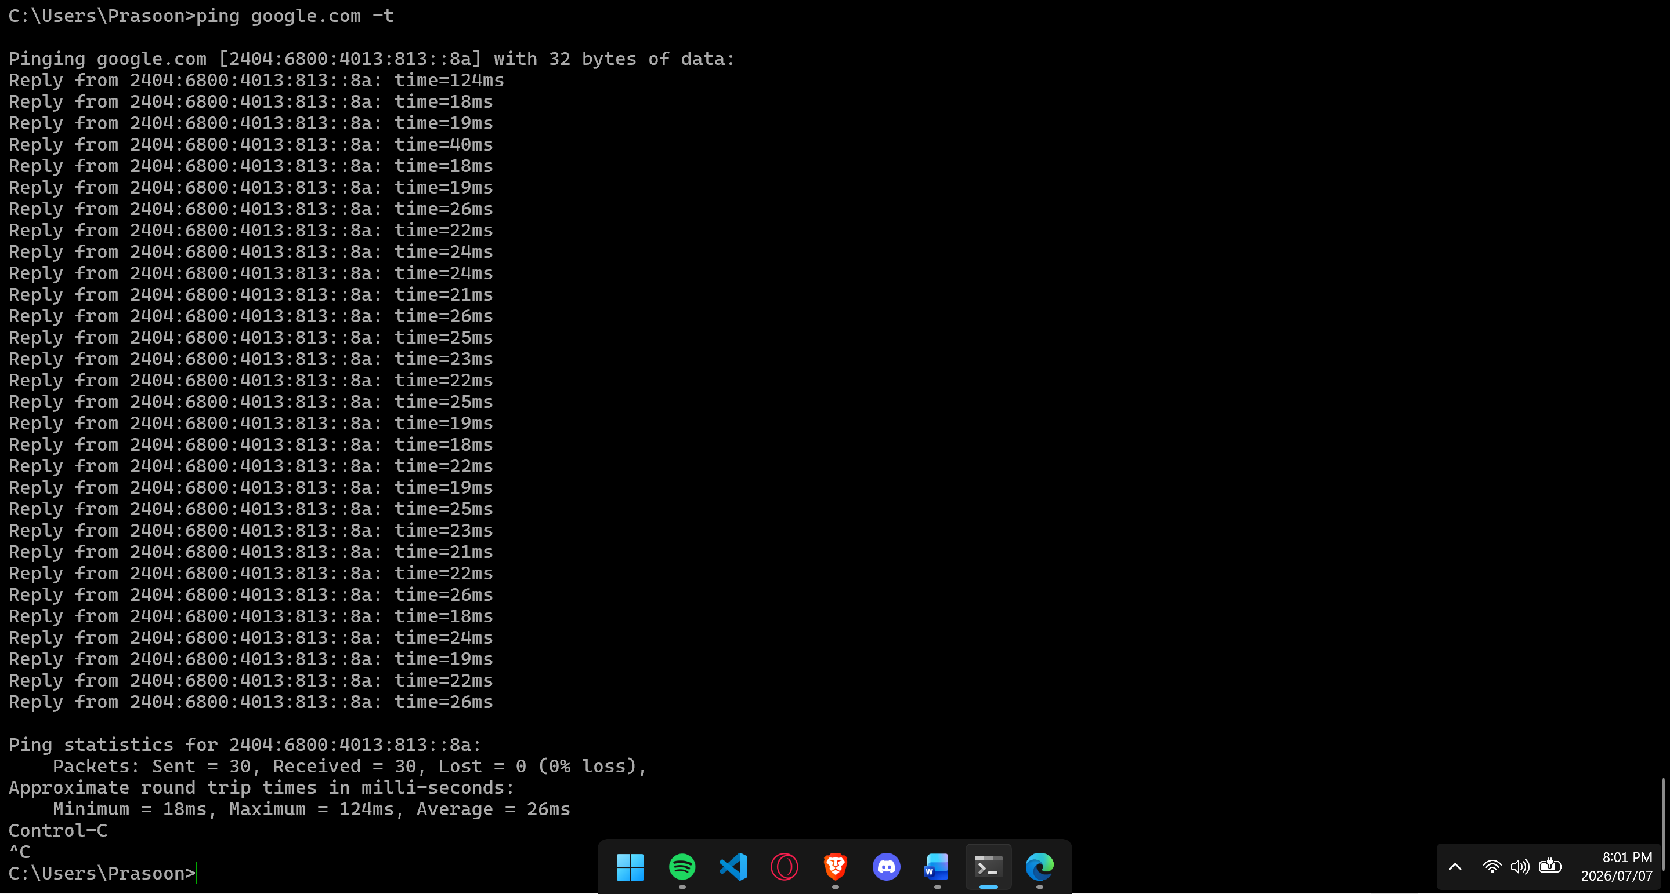

8. Ping with Custom Packet Size
i) Open Command Prompt.
ii) Execute: ping <website> -l 1000 -t
iii) Observe the continuous replies using a packet size of 1000 bytes. Stop the command using Ctrl + C.
Output: 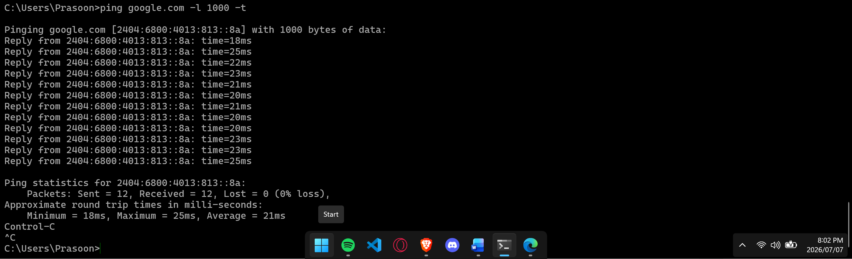

9. Tracing the Network Route
i) Open Command Prompt.
ii) Execute: tracert <website>
iii) Observe the sequence of network hops and their response times.
Output: 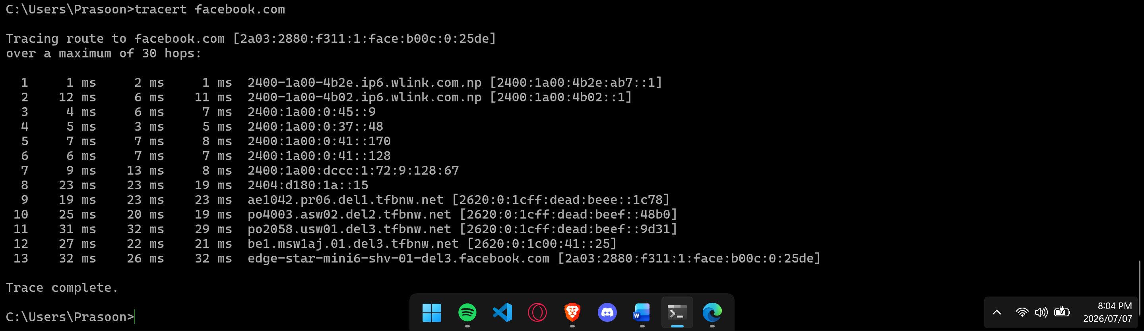

10. Starting NSLookup
i) Open Command Prompt.
ii) Execute: nslookup
iii) Observe the default DNS server information and enter interactive mode.
Output: 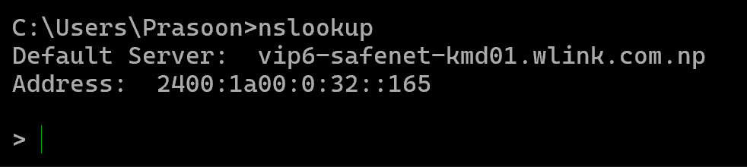

11. Querying a Website Using NSLookup
i) In NSLookup interactive mode, type: <website>
ii) Press Enter.
iii) Observe the DNS records and IP address returned for the website.
Output: 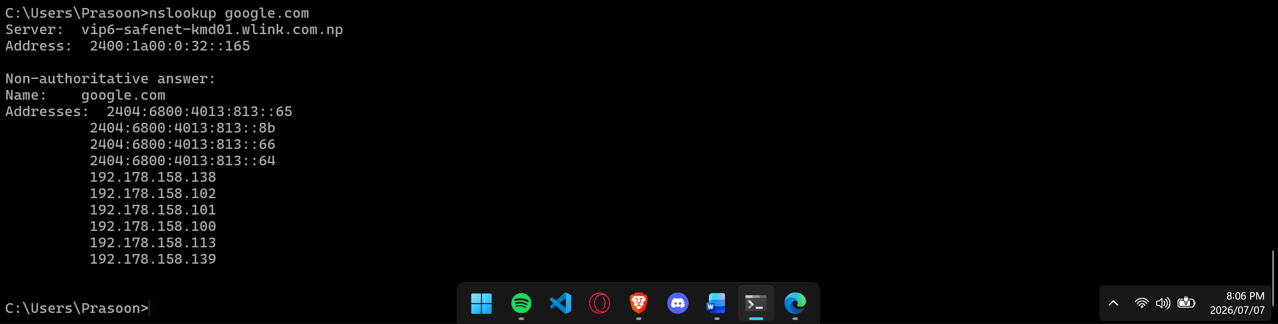

12. Viewing Active Network Connections
i) Open Command Prompt.
ii) Execute: netstat
iii) Observe the active network connections and protocol statistics.
Output: 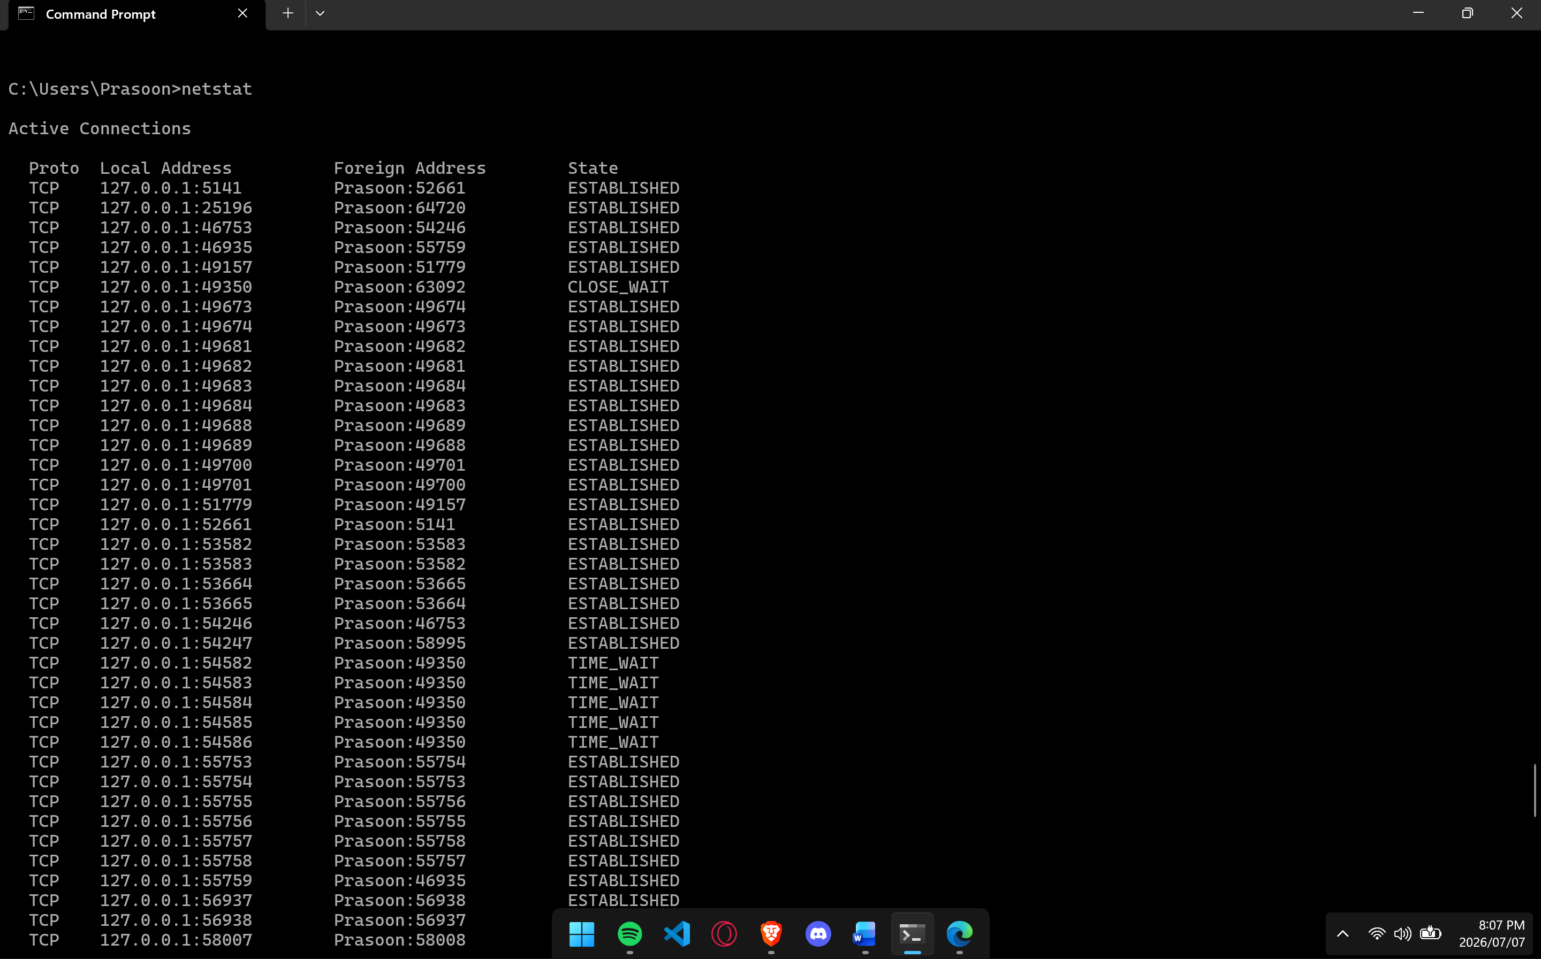

13. Viewing All Connections and Listening Ports
i) Open Command Prompt.
ii) Execute: netstat -an
iii) Observe all active connections and listening ports in numerical format.
Output: 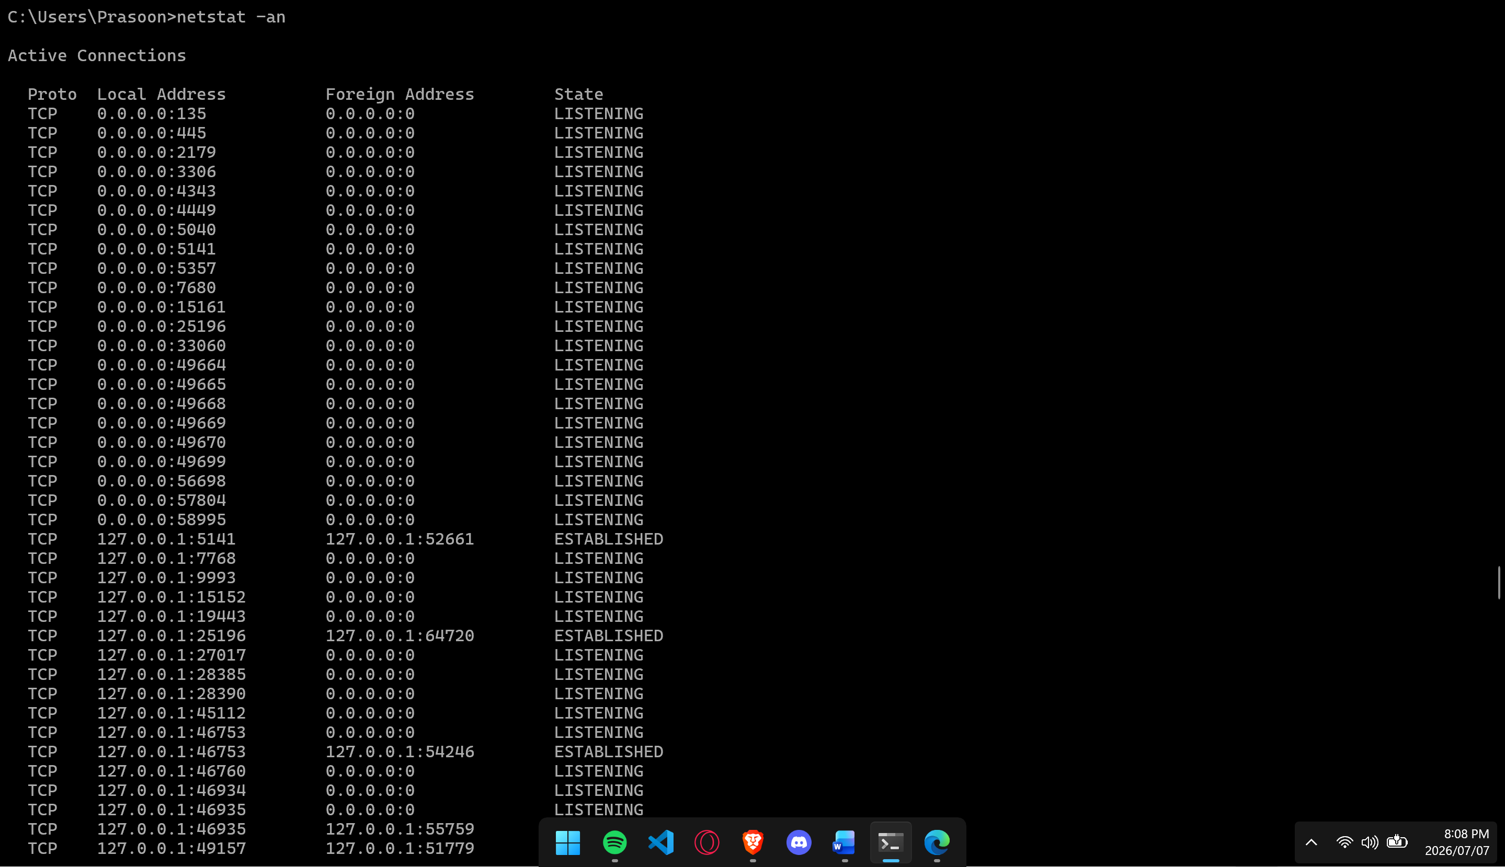

14. Displaying the ARP Cache
i) Open Command Prompt.
ii) Execute: arp -a
iii) Observe the IP address to MAC address mappings stored in the ARP cache.
Output: 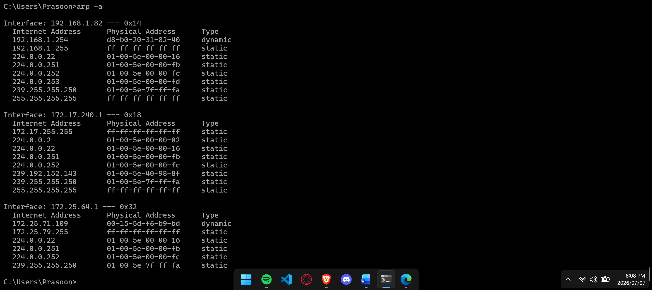

15. Displaying the Computer Name
i) Open Command Prompt.
ii) Execute: hostname
iii) Observe the hostname of the local computer.
Output:
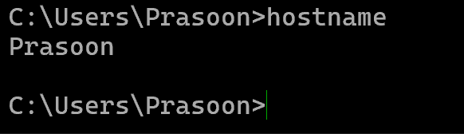

16. Viewing MAC Addresses
i) Open Command Prompt.
ii) Execute: getmac
iii) Observe the MAC addresses of the installed network adapters.
Output: 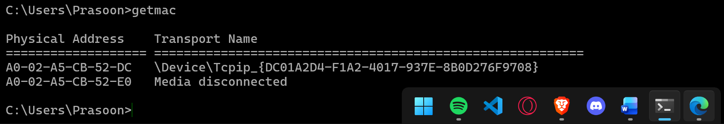

17. Viewing Shared Resources
i) Open Command Prompt.
ii) Execute: net share
iii) Observe the shared folders and resources available on the computer.
Output: 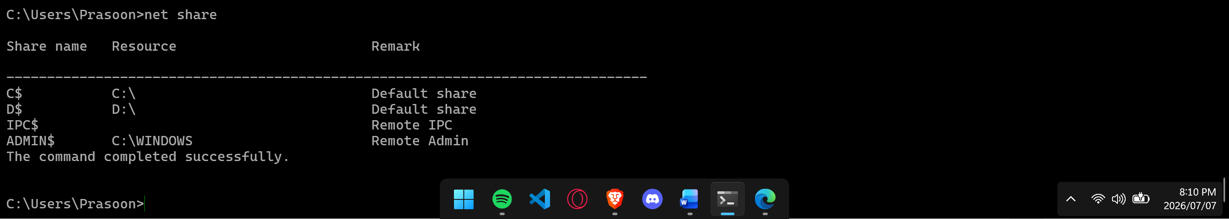

18. Viewing or Starting Services
i) Open Command Prompt.
ii) Execute: net start
iii) Observe the list of running services or start a specific service if specified.
Output: 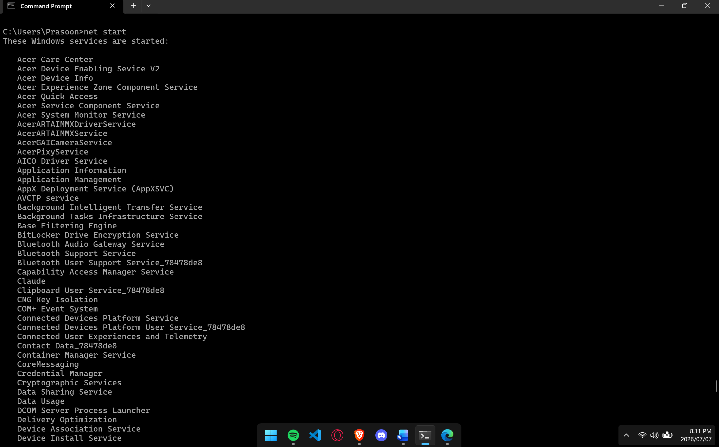

19. Stopping a Windows Service
i) Open Command Prompt.
ii) Execute: net stop <service_name>
iii) Observe the confirmation message indicating the service has been stopped.
Output:
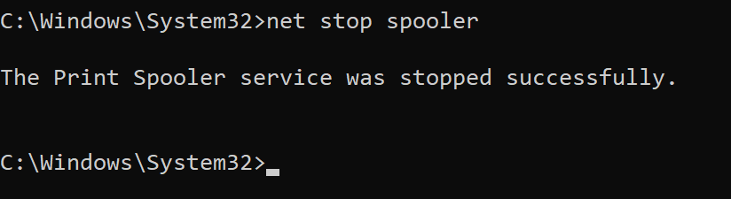

20. Changing the Command Prompt Color
i) Open Command Prompt.
ii) Execute: color <attribute> (e.g., color 0A)
iii) Observe the change in the Command Prompt text and background colors.
Output: 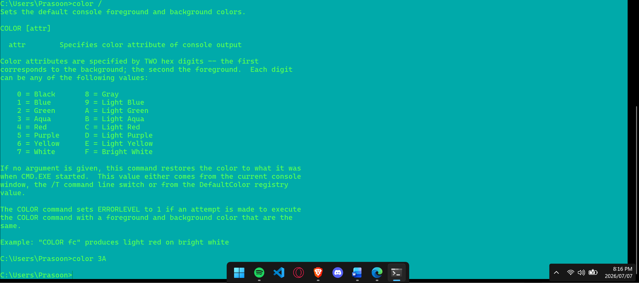

Conclusion
In this lab, various Windows networking utilities were studied and executed using the Command Prompt to understand their role in network configuration, troubleshooting, monitoring, and administration. Commands such as ipconfig, ping, tracert, nslookup, netstat, arp, hostname, getmac, net share, net start, net stop, and color were used to view IP configuration, manage DHCP settings, test network connectivity, trace packet routes, perform DNS queries, monitor network connections, inspect the ARP cache, identify system and adapter information, manage shared resources and services, and customize the Command Prompt interface. This experiment provided practical knowledge of essential Windows networking commands and their applications in diagnosing and managing network environments.

